

# Perth College

### Semester Two Examination, 2018

### Question/Answer booklet

# MATHEMATICS

If required by your examination administrator, please place your student identification label in this box

**METHODS**

**UNITS 1 AND 2**

## Section Two:

## Calculator-assumed

|  |  |  |  |  |  |  |  |  |  |  |
| --- | --- | --- | --- | --- | --- | --- | --- | --- | --- | --- |
| Student number: In figures |  |  |  |  |  |  |  |  |  |  |

In words

Your name

## Time allowed for this section

Reading time before commencing work: ten minutes

Working time: one hundred minutes

## Materials required/recommended for this section

***To be provided by the supervisor***

This Question/Answer booklet

Formula sheet (retained from Section One)

***To be provided by the candidate***

Standard items: pens (blue/black preferred), pencils (including coloured), sharpener,  
correction fluid/tape, eraser, ruler, highlighters

Special items: drawing instruments, templates, notes on two unfolded sheets of A4 paper, and up to three calculators approved for use in this examination

## Important note to candidates

No other items may be taken into the examination room. It is **your** responsibility to ensure that you do not have any unauthorised material. If you have any unauthorised material with you, hand it to the supervisor **before** reading any further.

## Structure of this paper

|  |  |  |  |  |  |
| --- | --- | --- | --- | --- | --- |
| Section | Number of questions available | Number of questions to be answered | Working  time (minutes) | Marks available | Percentage of examination |
| Section One:  Calculator-free | 8 | 8 | 50 | 54 | 35 |
| Section Two:  Calculator-assumed | 13 | 13 | 100 | 96 | 65 |
|  | | |  | **Total** | 100 |

## Instructions to candidates

1. The rules for the conduct of examinations are detailed in the school handbook. Sitting this examination implies that you agree to abide by these rules.

2. Write your answers in this Question/Answer booklet.

3. You must be careful to confine your response to the specific question asked and to follow any instructions that are specified to a particular question.

4. Supplementary pages for the use of planning/continuing your answer to a question  
have been provided at the end of this Question/Answer booklet. If you use these pages to continue an answer, indicate at the original answer where the answer is continued, i.e. give the page number.

5. Show all your working clearly. Your working should be in sufficient detail to allow your answers to be checked readily and for marks to be awarded for reasoning. Incorrect answers given without supporting reasoning cannot be allocated any marks. For any question or part question worth more than two marks, valid working or justification is required to receive full marks. If you repeat any question, ensure that you cancel the answer you do not wish to have marked.

6. It is recommended that you do not use pencil, except in diagrams.

7. The Formula sheet is not to be handed in with your Question/Answer booklet.

Section Two: Calculator-assumed 65% (96 Marks)

This section has**thirteen (****13)** questions. Answer **all** questions. Write your answers in the spaces provided.

Working time: 100 minutes.

Question 9 (5 marks)

The variables $x$ and $y$ are related by the equation $2x+3y=12$.

(a) Sketch the graph of this relationship. (2 marks)

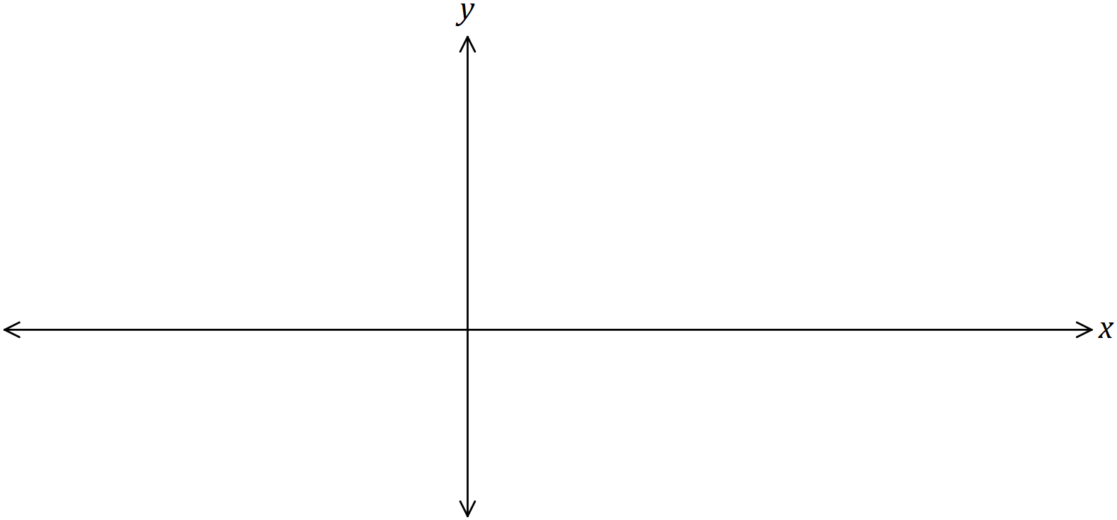

(b) Express $y$ in terms of $x$. (1 mark)

(c) Suppose the domain of $x$ is restricted to $-3<x≤9$. State the range of $y$. (2 marks)

Question 10 (6 marks)

(a) A sequence is defined by $T_{n+1}=T_{n}-2.4, T_{1}=875$. Determine

(i) the value of $T_{90}$. (1 mark)

(ii) the sum of the first $90$ terms of this sequence. (2 marks)

(b) Another sequence is defined by $T_{n}=875{\left(0.3\right)}^{n-1}.$ Determine

(i) the value of $T_{3}$. (1 mark)

(ii) the value $S_{90}$. (2 marks)

Question 11 (8 marks)

(a) Calculate the area of the minor segment that subtends an arc of $72°$ in a circle of diameter $170$ cm. (3 marks)

(b) A chord of length $26$ cm subtends an angle of $\begin{matrix}π \\ \overline{17}\end{matrix}$ at the centre of a circle. Calculate the radius of the circle. (2 marks)

(c) Parallelogram $PQRS$ has side $PQ=28$ cm, side $PS=19$ cm and an area of cm2. Determine the lengths of the diagonals of $PQRS$ to 1 decimal place. (3 marks)

Question 12 (8 marks)

The temperature $T$ of a cast taken out of an oven cools according to the model $T=960{\left(0.93\right)}^{t}$, where $t$ is the time in minutes since the cast was removed from the oven. $T$ is measured in $°C$.

(a) Determine the temperature of the cast after the first $3$ minutes. (1 mark)

(b) Graph the temperature of the cast against time on the axes below.

Provide a minimum of five points on the graph. (4 marks)

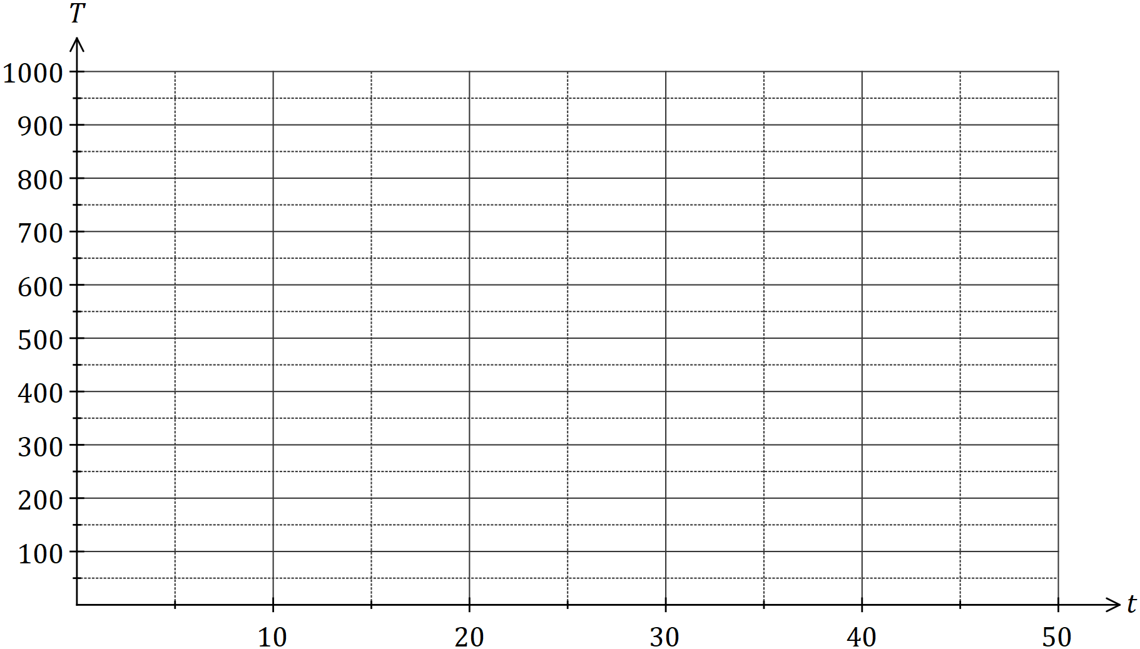

(c) The temperature of the cast falls to room temperature of $14°C$.

(i) Determine the time taken for the cast to reach room temperature. (2 marks)

(ii) Comment on the usefulness of the model for large values of $t$. (1 mark)

Question 13 (7 marks)

The probability of events $F$ and $N$ occurring are $0.52$ and $0.66$ respectively.

(a) Complete the following Venn diagram given $P\left(\overline{F∪N}\right)=0.09$. (2 marks)

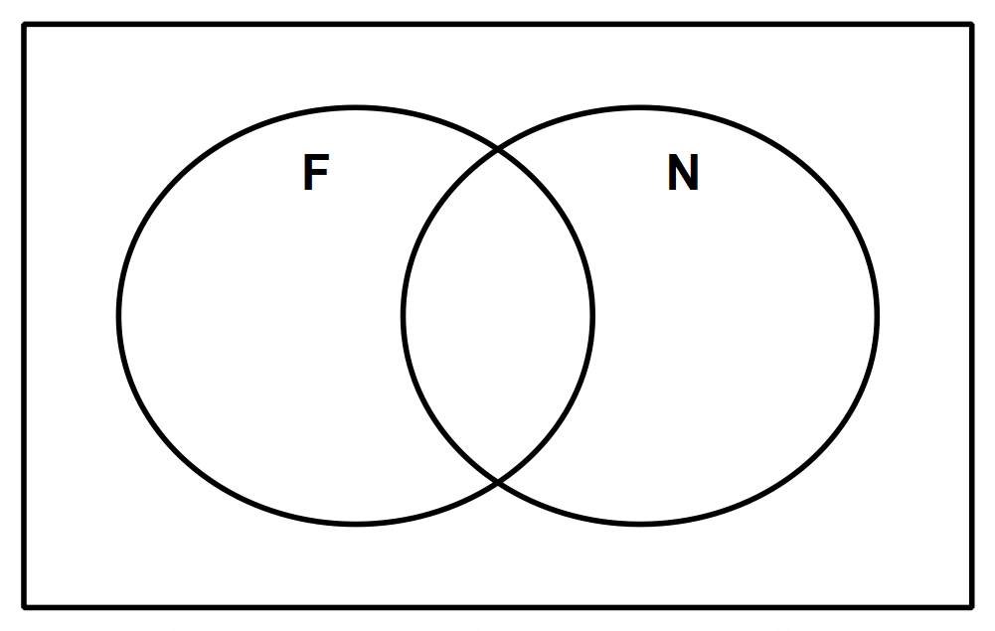

(b) Determine the following:

(i) $P\left(F∩N\right)$. (1 mark)

(ii) $P\left(N | \overline{F }\right)$. (2 marks)

(iii) $P\left(\overline{N} | (F∪N)\right)$. (2 marks)

Question 14 (10 marks)

A particle moves in a horizontal line from an initial point $150$ metres to the right of the origin. Its velocity, in m/s, can be mapped by the velocity function $v=-3t^{2}+44t-130$ for the first 13 seconds.

(a) What is the initial velocity of the particle, and describe the motion of the particle at this time. (2 marks)

(b) Determine when the particle is stationary. (1 mark)

(c) Determine the displacement function and hence, calculate the displacement of the particle at 13 seconds. (3 marks)

(d) Determine when particle is at the origin. (1 mark)

(e) Calculate the total distance travelled in the first 13 seconds to the nearest metre.

(3 marks)

Question 15 (7 marks)

(a) The graph of $y=\sin{x}$ is shown below. On the same axes, sketch $y=\sin{2x}$. (2 marks)

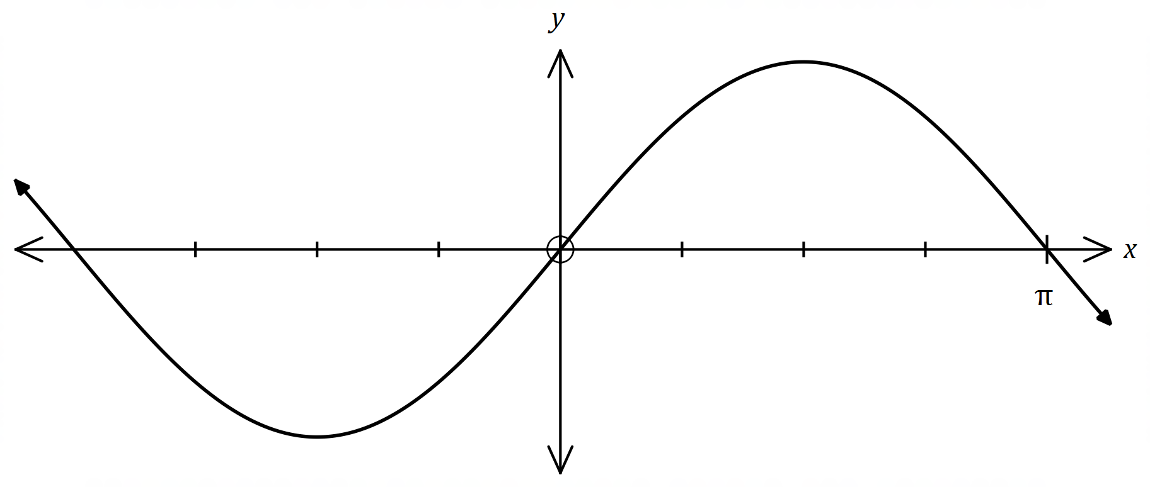

(b) The graph of $y=\tan{x}$ is shown below. On the same axes, sketch $y=\tan\left(x-\frac{π}{4}\right)$, and all its asymptotes. (3 marks)

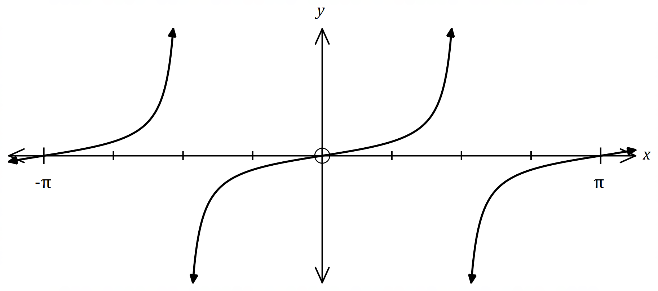

(c) The graph of $y=\cos{x}$ is shown below. On the same axes, sketch $y=\frac{1}{2}\sin\left(x+\frac{π}{2}\right)$.

(2 marks)

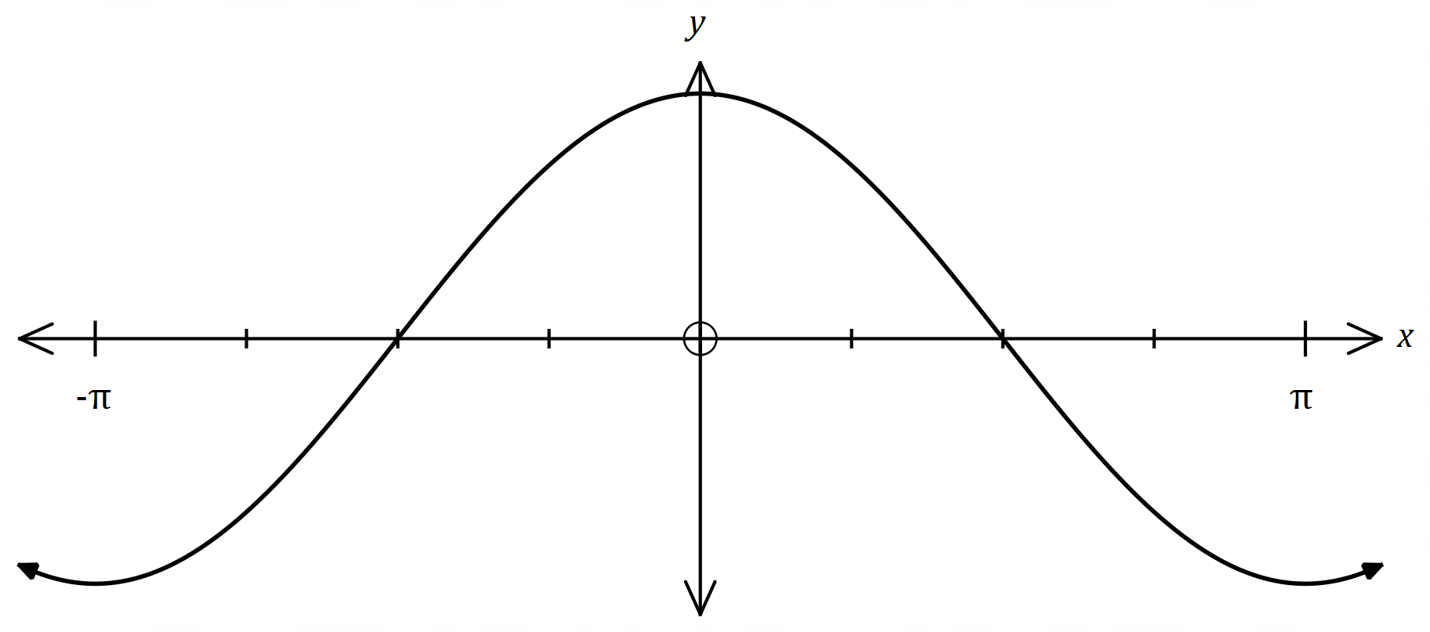

Question 16 (7 marks)

A council has three departments – Marketing, Web development and Design that work very closely together. There are $15$, $5$ and $10$ people in each department respectively and the mayor wishes to create a committee of $5$ employees from the three departments that will report directly to her.

(a) How many different committees are possible if there are no restrictions?

(1 mark)

(b) How many different committees are possible if Marketing must always be represented in the majority? (2 marks)

(c) How many different committees are possible if there must be at least one person from Web development? (2 marks)

In a pay review, $3$ employees from Marketing were given a pay rise whilst $1$ employee from Web development and $2$ from Design were given a pay rise.

(d) If the probability of receiving a pay rise is $0.2$, show that the probability of receiving a pay rise is independent of the department an employee works in. (2 marks)

Question 17 (8 marks)

A new brand of plant food is being tested on a seedling in a large greenhouse. The seedling responds well to the new plant food and grows rapidly. Each day, the seedling is observed to grown an extra $30\%$ of the growth achieved the previous day.

(a) Calculate the growth achieved by the plant on the th day if the seedling grew $2$ cm on the first day. (2 marks)

(b) Determine the height of the plant after $15$ days if the seedling had an initial height of $3$ cm. (2 marks)

Concerned that the plant will not fit in the greenhouse, the plant food is no longer applied, and on the th day and thereafter, the growth decreases by 60% each day.

(c) Write a recursive rule for the growth achieved by the plant for the th day and thereafter. (2 marks)

The greenhouse can only house plants shorter than $4$ metres.

(d) Will the greenhouse be able to house this plant? Explain. (2 marks)

Question 18 (7 marks)

(a) Part of the circle $x^{2}+y^{2}=ax+by+c$ is shown below. Determine the values of the constants $a, b$ and $c$. (4 marks)

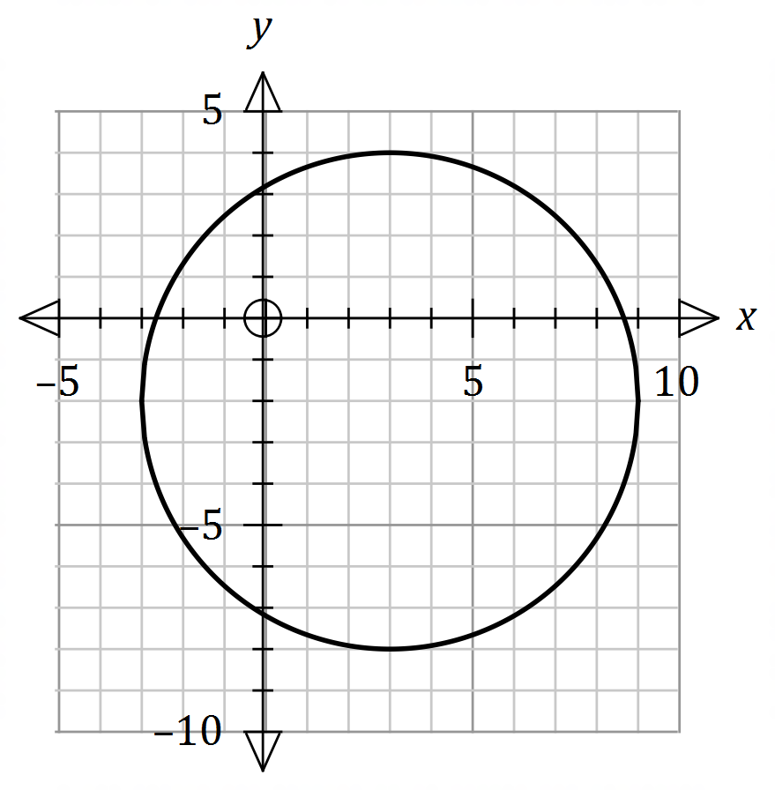

(b) The graph of a power function $y=g\left(x\right)$ is shown below.

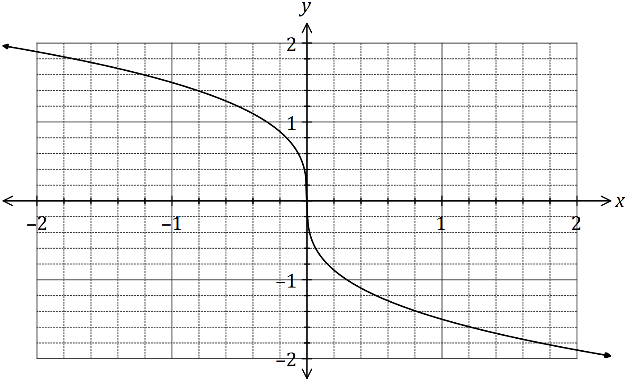

Use the graph to determine an estimate for the derivative of $g(x)$ when $x=-0.5$. (3 marks)

Question 19 (8 marks)

The height, $h$ metres, above level ground of a pod on the steadily rotating London Eye observation wheel $t$ minutes after a person enters a pod at the landing station is given by

$$h=67.5\sin\left(\frac{πt}{15}+24\right)+88, t≥0.$$

(a) Draw the graph of the height of the pod against time on the axes below, showing all key features. Label the key features of the graph correct to 1 decimal place (4 marks)

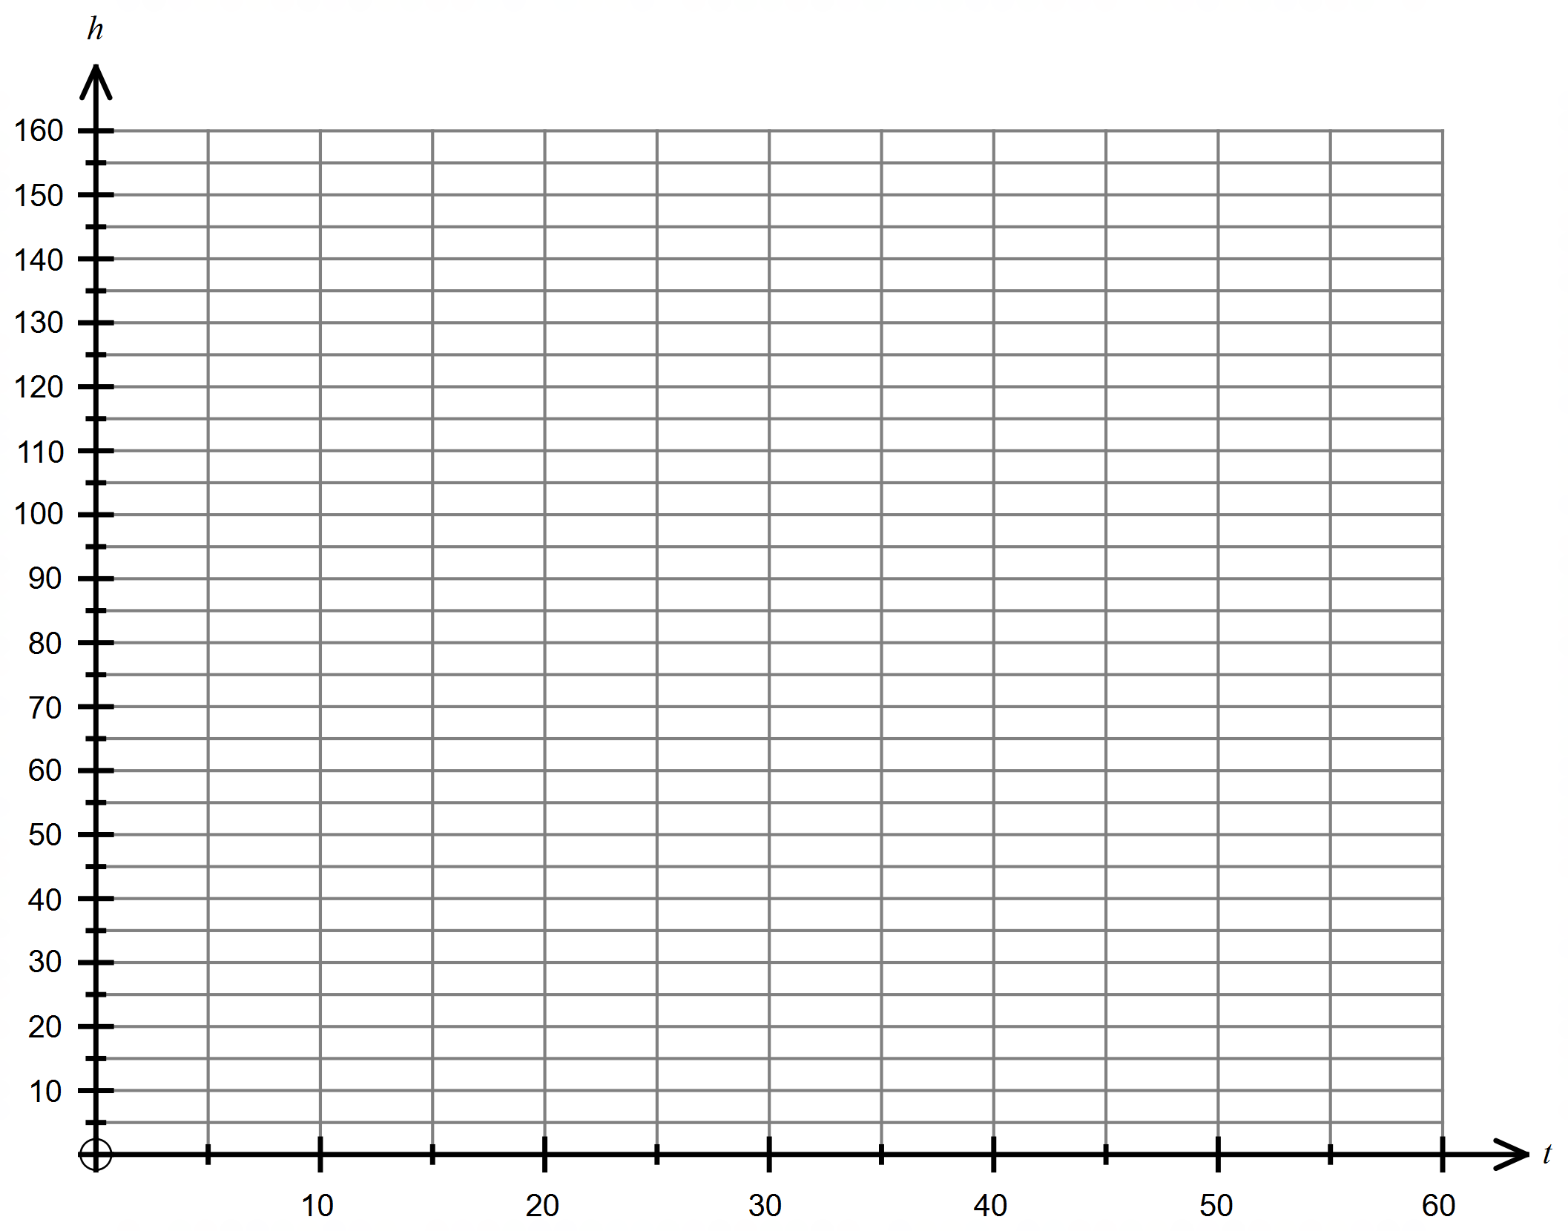

(b) How long does it take the London Eye to complete one revolution? (1 mark)

(c) How long, to the nearest minute, is the pod first reach a height of $100$ metres? (1 mark)

(d) What percentage, to the nearest whole, of an hour is spent at a height above $100$ metres? (2 marks)

Question 20 (9 marks)

A pyramid with a rectangular base of length $L$ and width $w$ has perpendicular height $h$. The length of the base is five times its width and the sum of the width, length and height is $117$ cm.

(a) Calculate the length, height and volume of the pyramid when $w=15$ cm. (2 marks)

Note: $V\left(pyramid\right)=\frac{1}{3} × Area of base × h$

(b) Show that the volume of the pyramid is given by $V=195w^{2}-10w^{3}$. (2 marks)

(c) Use calculus to determine the maximum volume of the pyramid and state the dimensions required to achieve this volume. (5 marks)

Question 21 (6 marks)

A rare disease in dogs is known to affect $0.4\%$ of all dogs, and the diagnostic test for the disease has a $98\%$ chance of giving a correct diagnosis. This means that there is a 98% chance that the test correctly determines a diseased dog has the disease, but a 2% chance that the test incorrectly determines that a diseased dog does not have the disease and vice versa.

If event $D$ is the probability of a dog having the disease, and event $C$ is the test giving a correct diagnosis, use the probability tree diagram below to help answer the following questions where $D$ and $C$ are independent events.

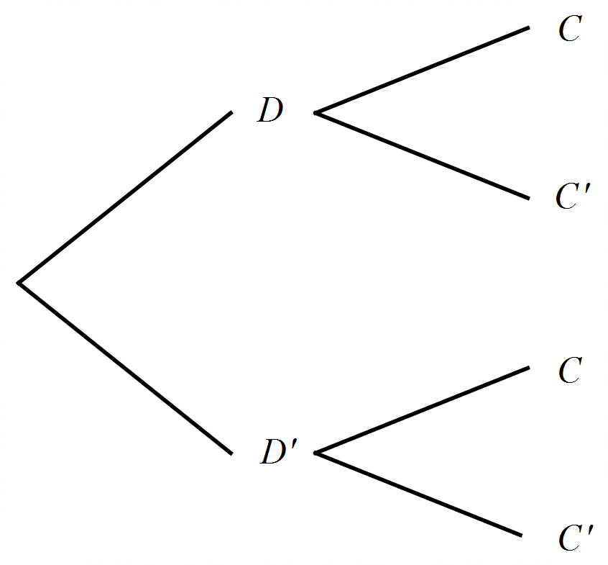

(a) Determine the probability that a randomly selected dog

(i) has the disease and the test correctly determines that it has the disease,

(1 mark)

(ii) has the disease and the test incorrectly determines that it does not have the disease, (1 mark)

(iii) is tested and the test indicates it has the disease. (2 marks)

(b) Two dogs are randomly selected for the test. Determine the probability that just one of the dogs is diagnosed correctly. (2 marks)

Supplementary page

Question number: _________

Supplementary page

Question number: _________

Supplementary page

Question number: _________

Supplementary page

Question number: _________

|  |  |  |
| --- | --- | --- |
| **Markers use only** | | |
| **Question** | **Maximum** | **Mark** |
| 9 | 5 |  |
| 10 | 6 |  |
| 11 | 8 |  |
| 12 | 8 |  |
| 13 | 7 |  |
| 14 | 10 |  |
| 15 | 7 |  |
| 16 | 7 |  |
| 17 | 8 |  |
| 18 | 7 |  |
| 19 | 8 |  |
| 20 | 9 |  |
| 21 | 6 |  |
| **S2 Total** | **96** |  |
| **S2 Weighted** | **65%** |  |

© 2018 WA Exam Papers. Perth College has a non-exclusive licence to copy and communicate this document for non-commercial, educational use within the school. No other copying, communication or use is permitted without the express written permission of WA Exam Papers. SN077-122-2.